**Exercise: Printer - GoF Strategy**

In this exercise you will work with the printer example from the class. We will make a simple program that allows the user to change printer type when the program is running.

We need a simple text editor and a number of printers.

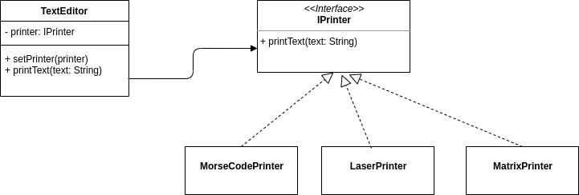

Our aim in this exercise is to design and implement a system that will allow us to easily change which printer is being used and let the user control while the program is running which printer is used.

**Exercise 1:**

Consider the design above. Do this design use the GoF Strategy pattern?

**Exercise 2:**

Create a Console application

**Exercise 3:**

Implement the classes above and create an instance of TextEditor in the Program.cs, with a specific printer type and print out some text.

*Note:* that your printers don’t have to do anything but print out the name of the class followed by the text.

**Exercise 4:**

In your Program.cs alter the code so that the user can alter which Printer object is used before printing – while the program is running.

*Hint:* use while-loop and switch/case to handle user input.

**Exercise 5 (optional):**

Alter you Program.cs so that you let the user specify some text in the console and then print via a (by the user) choosen printer.